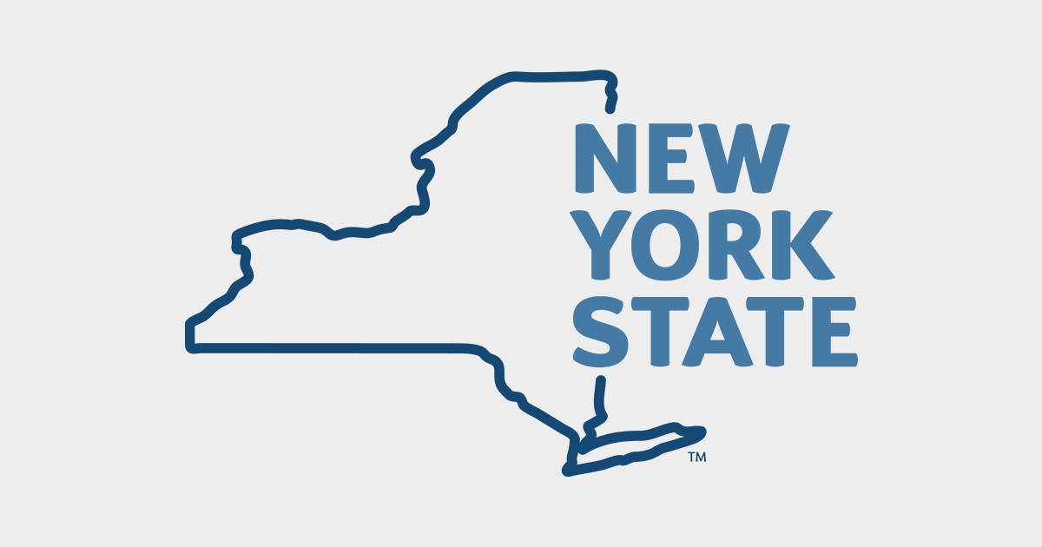
Parks
&
Recreation
Concept Document

Team:
Daniyal Shami
Davina Gurcharan

Table of Contents
1. Problem Statement
1.1 Who, What, Where, Why, and How
2. Mission Statement
2.1 Vision
2.2 Goals
3. Project Description
3.1 Business Purpose
3.2 Proposed Solution
4. Use Cases
4.1 Role-Based Login
4.2 View Park & Department Information
4.3 View Upcoming Events
4.4 Search Site & Events
4.5 AI Chatbot Interaction
4.6 Submit Donation
4.7 Create Client Account
4.8 Book Event Request
4.9 View Past Events
4.10 Cancel Event
4.11 Pay for Event Reservation
4.12 Receive Email Notification
4.13 View Notification Bell
4.14 Review Event Request (Approve/Deny)
4.15 Manage Employee Account (Create/Delete)
4.16 Create Employee Schedule
4.17 Review PTO Request (Approve/Deny)
4.18 View Schedule
4.19 Request PTO
5. Flow Chart Diagrams
5.1 Main System Flow
5.2 Event Booking Flow
5.3 Event Approval Flow
5.4 Payment & ID Verification Flow
5.5 Employee Scheduling Flow
5.6 PTO Request Flow
6. References
7. Key Terms
1. Problem Statement

The New York State Parks & Recreation website looks like a blast from the past. The site is totally outdated and a major pain to navigate. Are you trying to find information fast? Yes, not on the current NYS Parks and Recreation website. The entire site exudes prehistoric era programming. Technically speaking, it currently lacks a centralized, modern, digital platform that unifies park exploration, event booking, event management, administrative functionality, and statewide analytics into a single cohesive system. Existing Park websites either operate independently, which results in fragmented user experiences, or they just lack the tools that modern website boasts which render them a hassle to utilize. Admin portals are inefficient, which causes them to be. usage spike in cost for not only day to day function but developer maintenance and updating. The site has major reliability and speed flaws. It creates inconsistent design standards and limited functionality across all pages. Many platforms do not support real-time event booking, interactive mapping, structured admin management tools, integrated analytics dashboards, or comprehensive oversight of information. They particularly display inadequacy in the event display dashboard, and the live park related news and weather updates section.
Users often struggle to search for specific events efficiently. Users are unable to filter by location or category or compare park options or manage bookings in one centralized interface. Vendors face operational inefficiencies when configuring employee schedules, employee PTO requests, donations received, monitoring event capacity, and handling bureaucracy of the event booking procedure such as payments and id verification in case of emergencies and incidentals. Administrators lack real-time visibility into total user growth, user participation, and overall system performance metrics. The entire site has a broken / unlinked search feature and is totally missing a chat function with an AI agent to expedite information extraction and event planning. The donation feature is missing or hard to access as well.
Without a unified digital ecosystem, event discoverability remains limited; operational workflows remain manual or disconnected, and opportunities for increased community engagement are missed. A full fledge web application with multiple portals and modern features in addition to complete overhaul with efficiency and streamlining is highly required to modernize the digital infrastructure supporting New York State Parks and Recreation website and to also ensure long-term sustainability and growth.

1.1 Who, What, Where, Why and How
Who?
This website will primarily target New York State residents. Particularly those who often visit State Parks and/or participate in recreational events. The secondary target clients are users, tourists, and visitors. The website will be a warehouse of easily accessible information so it can also be frequented by students, researchers, auditors, news reporters and the naturally curios or people who just want reliable information related to NYS parks, amenities, and events. In addition to the public facing main page, the website will serve park administrators and park employees as their complete dashboard and control panel to operate the park and its activities day in and day out. Ongoing System maintenance, enhancement, and technical updates will be managed by an external team comprised of Software developers.

What?
The New York State Parks and Recreation website will be a modern, feature rich and practical retake on an outdated, fragmented, and inefficient system. The website will be a one stop shop for all things NYS parks related, serving as a digital hub for park information, event discovery, and administrative management. It will be AI powered to make it innovative and a fully interactive and personalized experience. The website will utilize the most up to date, complete, consolidated, and efficient technology stack available today. The site will be a role-based web platform that enables differentiated access to the public, clients, administrators, and employees. It will provide easy access to information and maps of parks across the state of NY and the department itself. The site will boast a search bar tool that can interact with all the information on the site and the upcoming events being hosted in the park using a variety of filters. The system will include an integrated event management workflow that supports booking requests, cancellations, approvals, denials, payment validation, and automated email/notification updates. Administrative users will have access to dashboards, notification alerts, employee scheduling tools, PTO management features, and operational oversight capabilities. The website will prioritize usability, responsiveness, clean UI, accessibility, and performance via an easy to navigate intuitive interface.

Where?
The platform will serve all New York State Parks and recreational areas. It will be accessible through modern desktops, laptops, iPad, and cell phones; all web-enabled and capable devices. The website will also be programmed to support and enhance mobile web browsers using responsive design principles and easy flow of S.M.A.R.T. ideologies. This will enable easy viewability across various screen sizes and devices in addition to consistency of design and functionality.

Why?
The website is necessary to improve accessibility and ease of use overall. The current website lacks luster, slow and outdated. There is a serious deficit in the functionality of the recreational opportunities section and a major need to enhance the overall user experience for both public visitors and internal users. The current fragmented system limits event discoverability, creates administrative inefficiencies, and reduces network traffic and user engagement. By modernizing the digital infrastructure and rebuilding the website completely, the new platform will streamline workflows, reduce manual processing, and increase participation in Park events statewide. It will also provide administrators with improved visibility into user engagement, participation of metrics, donations, and event bookings. The new website will be more efficient, accessible, and data-informed Ai system that strengthens community engagement and NYS digital infrastructure, while supporting long-term sustainability and growth for New York State Parks.

How?
By implementing a secure and scalable web application which integrates role-based authorization and access control. It will host a centralized data management system with API to include maps and ai chatbots. The website will require multiple modules, portals, webpages, assets, API keys, and engines. The platform will incorporate advanced search and filtering mechanisms, structured event workflows that include booking, approval or denial, payment validation, and cancellation processes, and a notification system that supports both email and dashboard alerts. The site will host a donation feature and collect multiple metrics. Administrative dashboards will provide visualized performance metrics and system insights, while employee scheduling and PTO management tools will streamline internal operations. An AI-powered chatbot assistant will enhance user support by assisting in retrieving information quickly and helping in planning events. Through the integration of these components into a cohesive architecture, the system will deliver a unified digital hub that modernizes operations and improves user engagement across New York State Parks.

2. Mission Statement
The mission of the New York State Parks and Recreation website is to serve as the official, new, and improved: centralized gateway to all park-related information. Such as department info, park services, recreational events, and administrative operations across the state. The system is designed to modernize and unify the digital infrastructure supporting New York State Parks by connecting guests, clients, park administrators, and employees through a secure, scalable, and user focused, dynamic web application. By replacing inefficient systems and outdated workflows with an integrated role-based architecture, the website will streamline park exploration, information searching, event planning, event booking, event management, employee scheduling, PTO processing, and administrative metrics, donations and more.
The platform aims to significantly improve public accessibility to recreational opportunities by providing intuitive navigation system of tiles and boxes design, interactive park maps tool, centralized listings, advanced search capabilities, AI-assisted information retrieval, and simplified reservation functionality. Clients will benefit from a streamlined booking experience that includes event booking submission, cancellation management, payment validation, identification uploading, and automated email notifications. Administrators will gain structured tools in a dashboard overview, where they can review all requests for events and PTO via a notification hub. Administrators will easily be able to create and update employee schedules, approve, or deny PTO, monitoring notifications, and view event and donation metrics along with network traffic and other analytics. Employees will have direct access to their schedules and PTO submission tools, in addition to the general site for news alerts and park updates. This will reduce manual communication gaps and administrative delays.
Beyond functional improvements, the system seeks to increase statewide engagement with New York State Parks by making information more discoverable and easily searchable. We aim to make events more accessible, and workflows more efficient using ai to assist in planning. By centralizing data and modernizing digital services, the platform will support data-informed decision-making and reduce inefficiencies and strengthen long-term sustainability. An updated website will cater and appeal to a larger audience which will result in a stronger community participation, promote healthy outdoor lifestyles, and ensure that New York State Parks are supported by a modern digital foundation capable of adapting and scaling to future growth and technological advancement.

3. Project Description
The New York State Parks and Recreation website is a multi-role-based web application, which is designed to centralize park exploration, event booking, administrative management, and employee operations into a single integrated digital ecosystem. The platform replaces old and outdated park websites with a unified interface that supports easy public access and site navigation, client booking workflows, administrative oversight, and internal employee scheduling, amongst other modern capabilities.
The system features a public-facing homepage that highlights park information, park maps, and upcoming events, along with a global search tool that enables users to locate parks and events efficiently. An interactive statewide map integrated via API’s provides location-based navigation and improved discoverability. The platform integrates an AI-powered conversational chatbot assistant to help users retrieve information without searching and planning events and ask questions which may not be directly available on the website. The ai chatbot will also assist in exploring park options. This feature is currently unavailable on the NYS Parks website and would completely overhaul the user experience and how the website is utilized. The feature will be implemented via ChatGPT/Google Gemini/Copilot AI API engines. Public users may browse information freely, register as clients, and submit donations through a secure and streamlined interface. Public users may also donate to the parks by signing up or logging in; this will assist the parks in securing funding for park operations and materials.
Registered clients will gain access to a dedicated portal where they can view all their event bookings, submit new event booking requests, manage current event reservations, and cancel events. Clients will be able to use the payment portal to complete payment validation for approved event reservations. The document upload feature will enable clients to upload the required identification. These features amongst others are tied to an automated email notifications system that can alert the clients when event statuses change and other notifications. This structured event lifecycle workflow improves transparency and simplifies the reservation process for both clients and administrators.
The administrative portal provides a main dashboard that is easy to view and understand and navigate amongst a multi-tier of analytics. It will be littered neatly with structured tools for reviewing notifications received for PTO and events. The dashboard will allow park administrators to seamlessly approve or deny event requests, managing employee accounts by creating and deleting them. Create and update employees' schedule, approve or deny PTO requests and this is all tied to the email notification system to alert clients of changes. By centralizing these operational tools, the system reduces manual processing, improves internal coordination, and enhances overall efficiency. Employees access a dedicated portal where they can view assigned schedules and submit PTO requests, ensuring streamlined communication between staff and management.

3.1 Business Purpose
The primary business purpose of the platform is to modernize and centralize the digital infrastructure supporting New York State Parks. By consolidating park information, event management workflows, employee scheduling, and administrative oversight into a single system and building in modern tools such as search bars, filtering options, role based, event directed systems and ai chatbots; the platform aims to increase statewide event participation, improve discoverability of recreational opportunities, and reduce operational inefficiencies. The system enhances the ease of the event booking process, streamlines employee management, and provides administrators with improved visibility into park activity and operational performance. Through modernization and integration, the platform supports long-term sustainability and scalability. It also improves public service with a modern UI.

3.2 Proposed Solution
The proposed solution is a secure, scalable, role-based web application that integrates public access features with structured administrative tools. The platform will implement role-based authentication supporting Guest, Client, Park Administrator, and Employee access levels. It will incorporate centralized search functionality with keyword and filter capabilities, an event lifecycle workflow that includes request submission, administrative review, approval or denial, payment validation and documentation upload, and cancellation management, and a notification system that delivers both email and in-application alerts.
Administrative interfaces will support employee account management, event scheduling, and PTO request processing, while employee portals will provide schedule visibility and time-off submission tools. The AI-powered conversational assistant will enhance user experience by providing guided support and information retrieval. The system will be built using responsive front-end design principles, scalable backend services, secure database architecture, and cloud-based hosting infrastructure to ensure reliability, accessibility, and future scalability.

4. Use Cases & diagrams

Guest (Public Landing)
- View Site Info – all pages, FAQ, contact, etc.
- View Park Info
- View Map
- Search Site / Search Events (AI search optional)
- View Upcoming Events
- AI Chat
- Donate
- Register Account (Sign Up)
- Login
- Reset Password

Client (Client Portal)
- View Dashboard / My Events (current, pending, past + payment details)
- Create Event Request (Book Event)
- Cancel Event Request
- Upload ID Verification
- Pay Reservation Fee (Mock Validation)

Admin (Admin Portal)
- View Pending Event Requests
- Approve/Deny Event Request
- View Admin Notifications (bell icon: event/PTO requests)
- View Dashboard Analytics
- Create Employee Account
- Delete Employee Account
- Reset Employee’s Password
- Create/Update Employee Schedule
- View PTO Requests
- Approve/Deny PTO

Employee (Employee Portal)
- View Schedule
- Submit PTO Request

TOTAL: 27 use cases
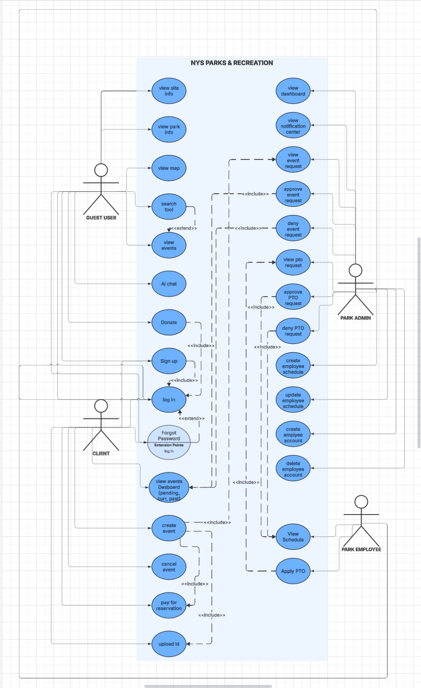
GUEST USER / (MAIN LANDING PAGE) USE CASES

4.1
UC-LOGIN: Role-Based Login (All Roles)

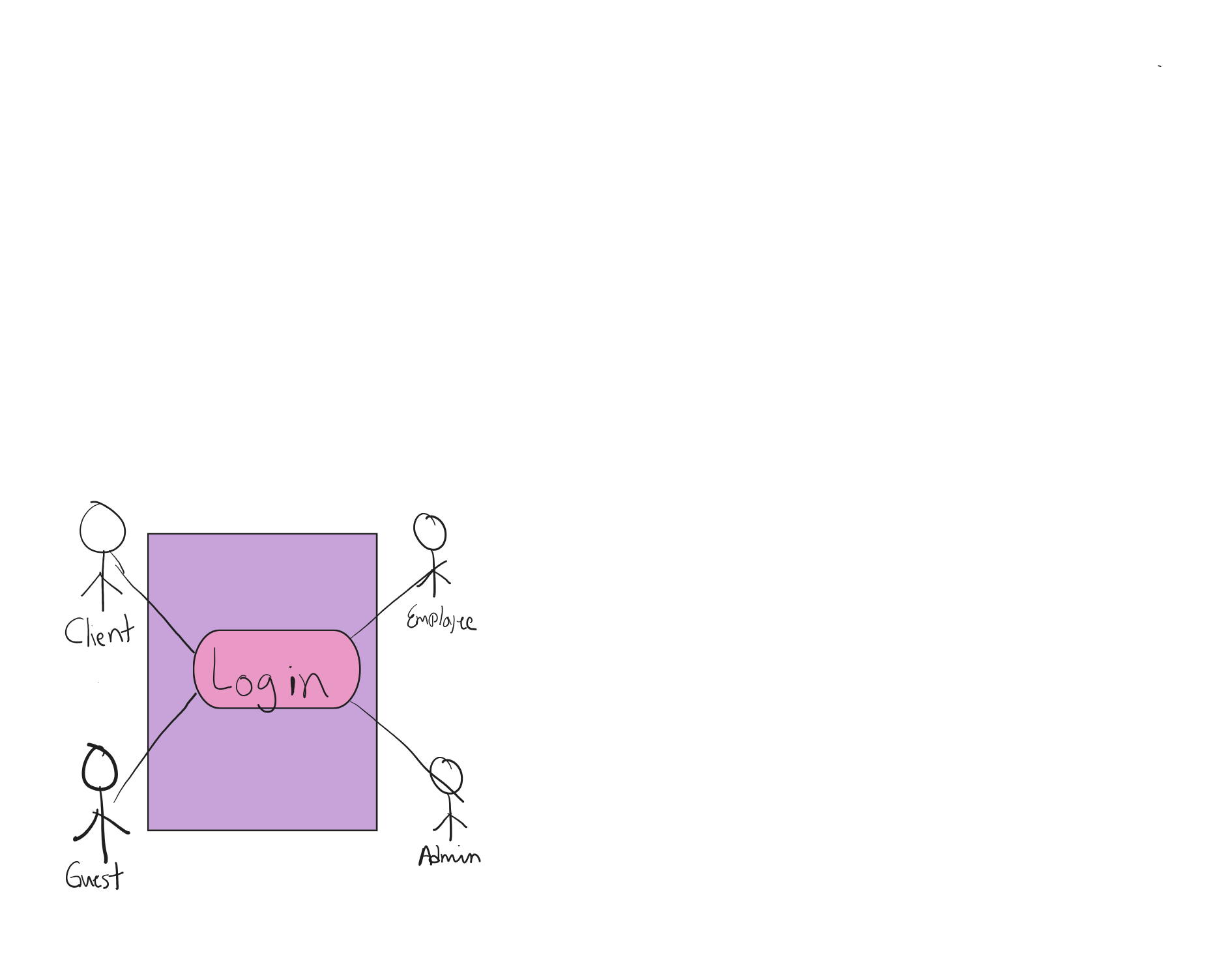
Use Case Name: RoleBasedLogin
Participating Actors: Client, Park Admin, Employee
Description: Allows any registered user to log in from the main landing page. The system identifies the user’s role and routes them to the appropriate portal.
Flow of Events:
- Actor navigates to the main website landing page.
- Actor selects “Log In.”
- System displays login form (email/username and password).
- Actor enters credentials and submits.
- System validates credentials.
- System retrieves actor role (Client/Admin/Employee).
- System redirects actors to the appropriate dashboard.
Entry Condition: Actor has an existing account.
Exit Conditions:
- Successful login and redirection to portal
OR
- Login failure message displayed.
Alternative Path:
- If credentials are invalid, system displays error and allows retry.
- If account is locked or disabled, system blocks login and displays message.

4.2
UC-VIEW-INFO: View Park & Department Information
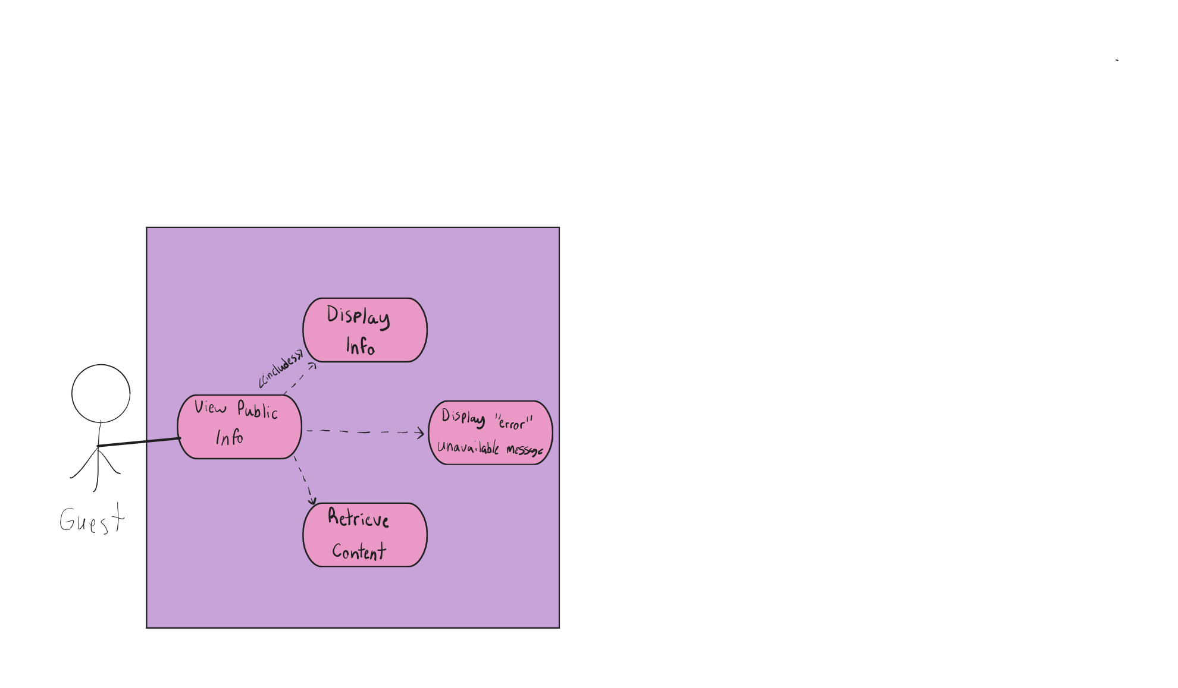
Use Case Name: ViewPublicInformation
Participating Actors: Guest
Description: Allows a guest to browse park information, department information, maps, FAQs, and contact details.
Flow of Events:
- Guest opens the landing page.
- Guest selects a tab (Parks, Maps, FAQ, Contact, etc.).
- System retrieves requested content.
- System displays information.
- Guests may navigate to other sections.
Entry Condition: None.
Exit Conditions:
- Requested information displayed
OR
- “Content unavailable” message displayed.

4.3
UC-VIEW-EVENTS: View Upcoming Events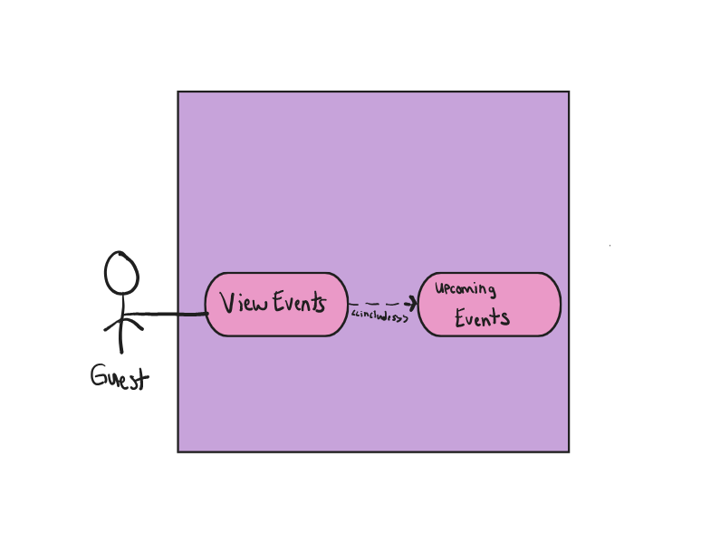

Use Case Name: ViewUpcomingEvents
Participating Actors: Guest
Description: Allows guest users to view upcoming events and filter/search results.
Flow of Events:
- Guest selects “Events.”
- System retrieves upcoming events.
- System displays event list sorted by date.
- Guest applies filters or search terms (optional).
- System updates results.
- Guest selects event to view details.
Entry Condition: None.
Exit Conditions:
- Events displayed
OR
- “No events found” message displayed.
Alternative Path:
- If search returns zero results, system prompts user to modify filters.

4.4
UC-SEARCH: Search Bar Tool (Site / Events)
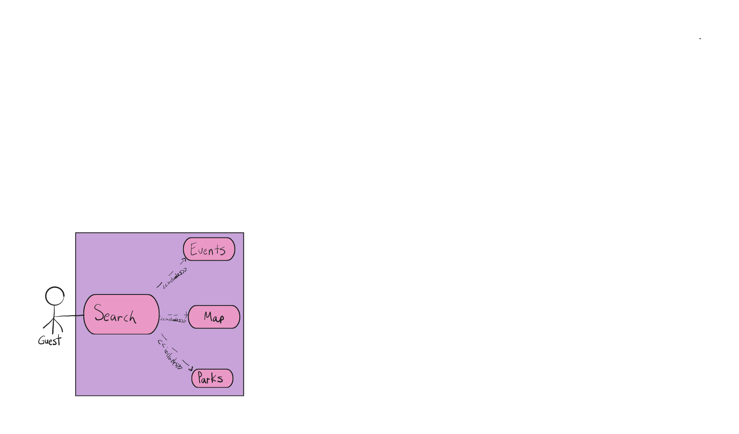
Use Case Name: GuestSearch
Participating Actors: Guest
Description: Allows a guest to search site content and event listings using the main search bar.
Flow of Events:
- Guest enters keyword into search bar.
- Guest selects search type (Site / Events) if applicable.
- System validates input.
- System queries database/content.
- System displays matching results.
- Guest selects a result.
- System opens selected page.
Entry Condition: None.
Exit Conditions:
- Search results displayed
OR
- “No results found” message displayed.
Alternative Path:
- If search field is blank, system prompts user to enter text.

4.5
UC-CHATBOT: AI Chatbot
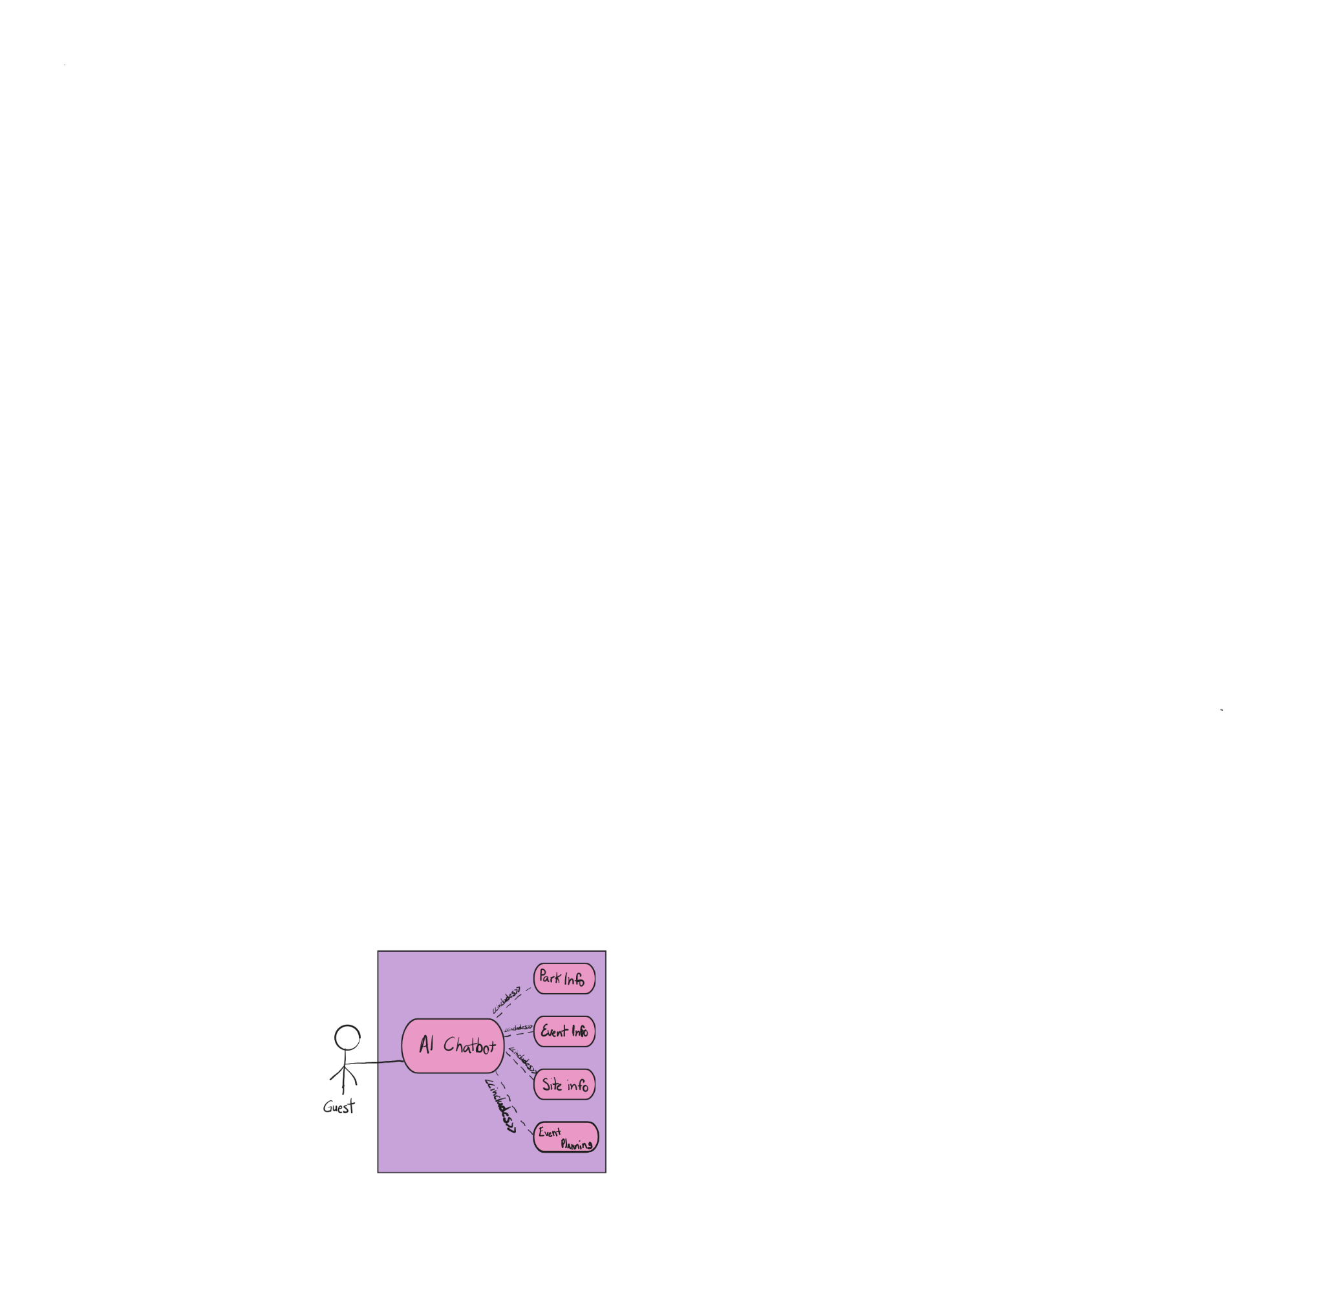
Use Case Name: GuestAIChatbot
Participating Actors: Guest
Description: Allows Guest to interact with AI chatbot to retrieve park, event, or general site information.
Flow of Events:
- Guest selects chatbot icon.
- System opens chat interface.
- Guest submits question.
- System processes request.
- System displays response and relevant links.
- Guest may continue conversation or close chat.
Entry Condition: None.
Exit Conditions:
- Guest receives relevant response
OR
- System displays fallback message.
Alternative Path:
- If chatbot cannot provide an answer, system suggests FAQ or contact page.

4.6
UC-DONATE: Submit Donation

Use Case Name: GuestDonate
Participating Actors: Guest
Description: Allows a guest to submit a donation through the website.
Flow of Events:
- Guest selects “Donate.”
- System displays donation form.
- Guest enters required details and donation amount.
- Guest submits form.
- System validates information.
- System records donation.
- System displays confirmation.
Entry Condition: None.
Exit Conditions:
- Donation successfully recorded
OR
- Validation error displayed

4.7
UC-REGISTER: Create Account
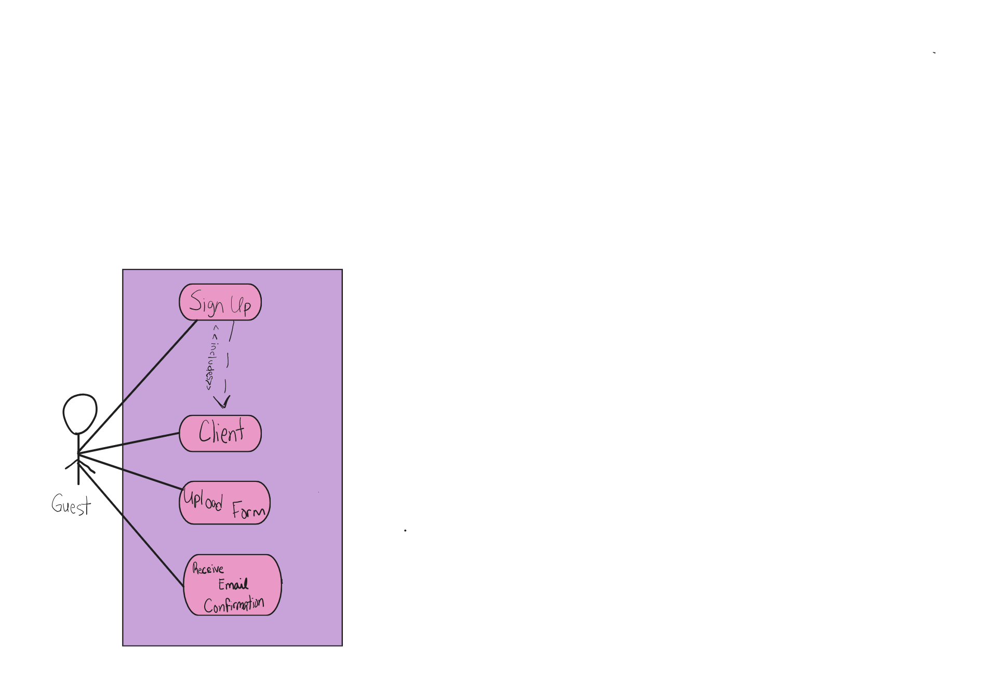
Use Case Name: CreateAccount
Participating Actors: Guest
Description: Allows a guest to register as a client. (Employee accounts are created by Admin; Admin accounts by Developer. Only client can make an account by pressing sign up button on the public website)
Flow of Events:
- Guest selects “Sign Up.”
- System displays registration form.
- Guest enters required information.
- Guest submits form.
- System validates inputs.
- System creates client account.
- System displays confirmation.
Entry Condition: Guest not logged in.
Exit Conditions:
- Account created successfully
OR
- Validation/duplicate error displayed
CLIENT (CLIENT PORTAL) USE CASES

4.8
UC-BOOK-EVENT: Book Event
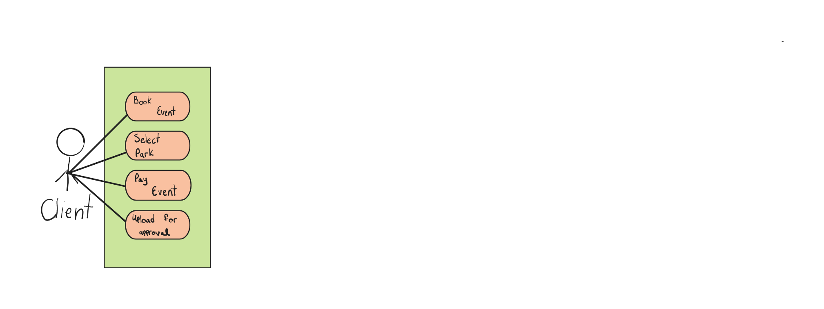
Use Case Name: BookEvent
Participating Actors: Client
Description: Allows client to submit a new event reservation request.
Flow of Events:
- Client logs in.
- Client selects “Book Event.”
- System displays event form.
- Client enters event details.
- Client submits request.
- System records event as “Pending.”
- System notifies Admin.

Entry Condition: Client logged in.
Exit Conditions:
- Event request recorded
OR
- Validation error displayed

4.9
UC-VIEW-PAST: View Past Events
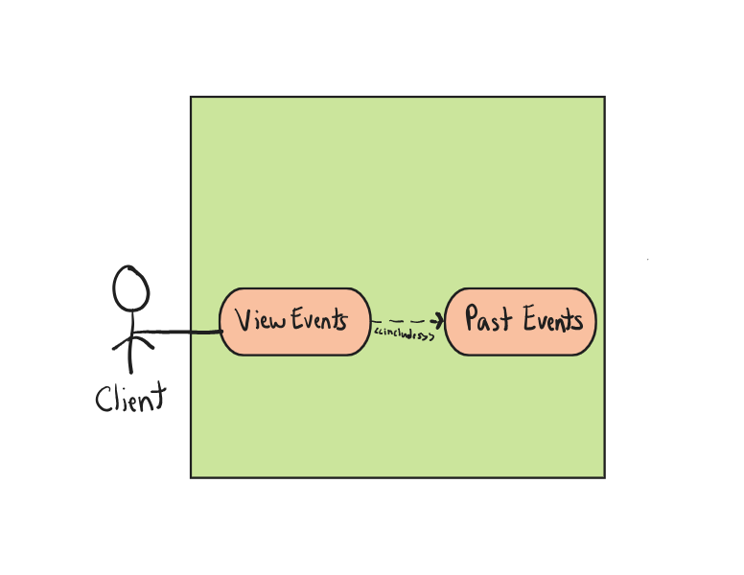
Use Case Name: ViewPastEvents
Participating Actors: Client
Flow of Events:
- Client selects “Past Events.”
- System retrieves client’s past events.
- System displays list.
Entry Condition: Client logged in.
Exit Conditions:
- Events displayed
OR
- “No past events” message displayed

4.10
UC-CANCEL-EVENT: Cancel Event
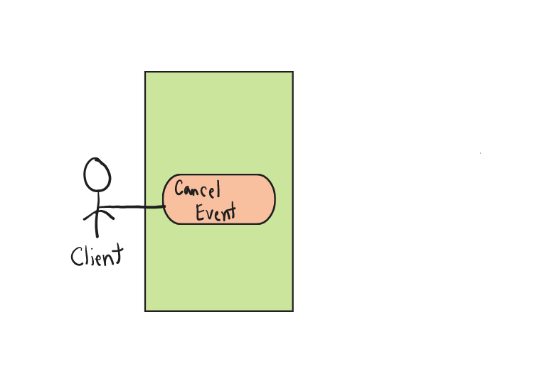
Use Case Name: CancelEvent
Participating Actors: Client
Flow of Events:
- Client selects Event.
- Client selects “Cancel.”
- System requests confirmation.
- Client confirms.
- System updates event status to “Cancelled.”
- System notifies Admin.
Entry Condition: Event exists and is eligible for cancellation.
Exit Conditions:
- Event cancelled
OR
- Cancellation not permitted message displayed

4.11
UC-PAY-EVENT: Pay for Event Reservation
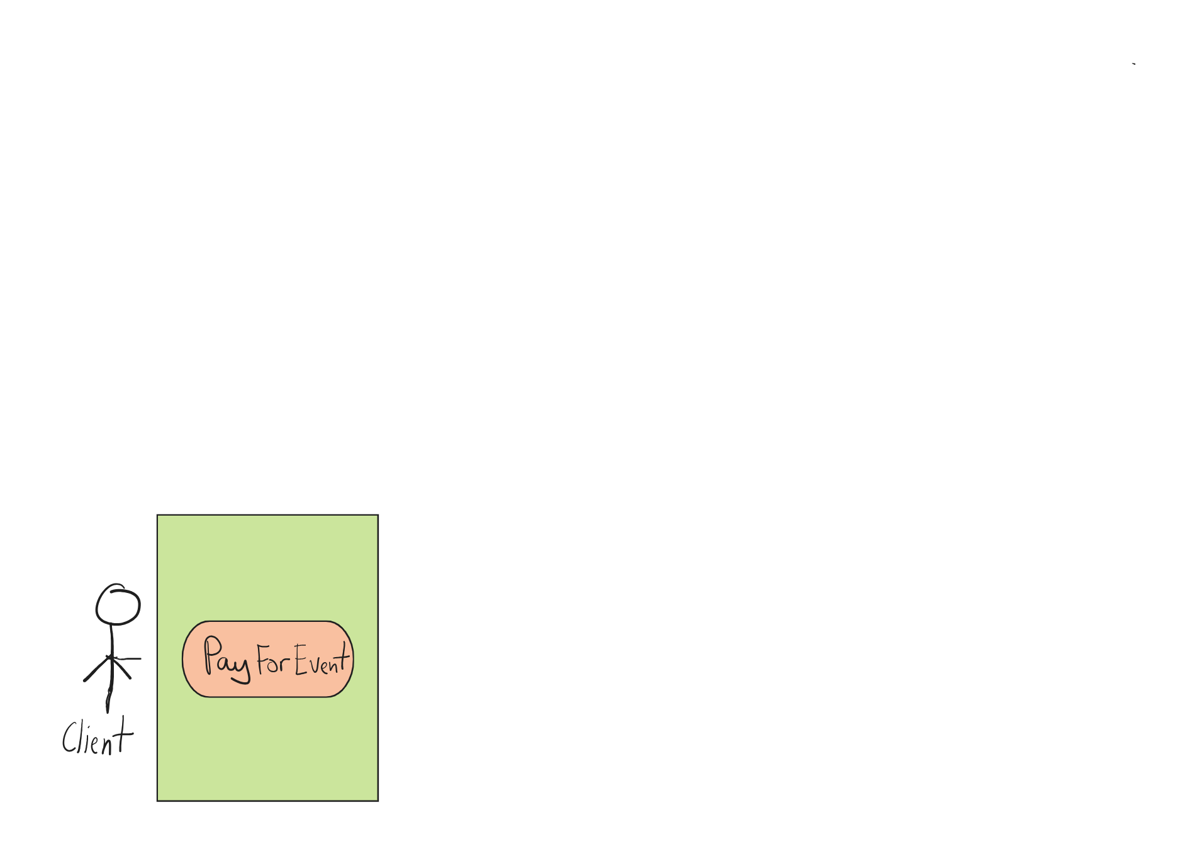
Use Case Name: PayForEvent
Participating Actors: Client
Flow of Events:
- Client selects approved event requiring payment.
- Client selects “Pay Now.”
- System displays payment form.
- Client enters payment details.
- System validates payment (mock validation).
- System records payment and updates status to “Paid.”
- System confirms payment.
Entry Condition: Event approved and payment required.
Exit Conditions:
- Payment processed
OR
- Validation failure displayed

4.12
UC-EMAIL-NOTIF: Receive Email Notification
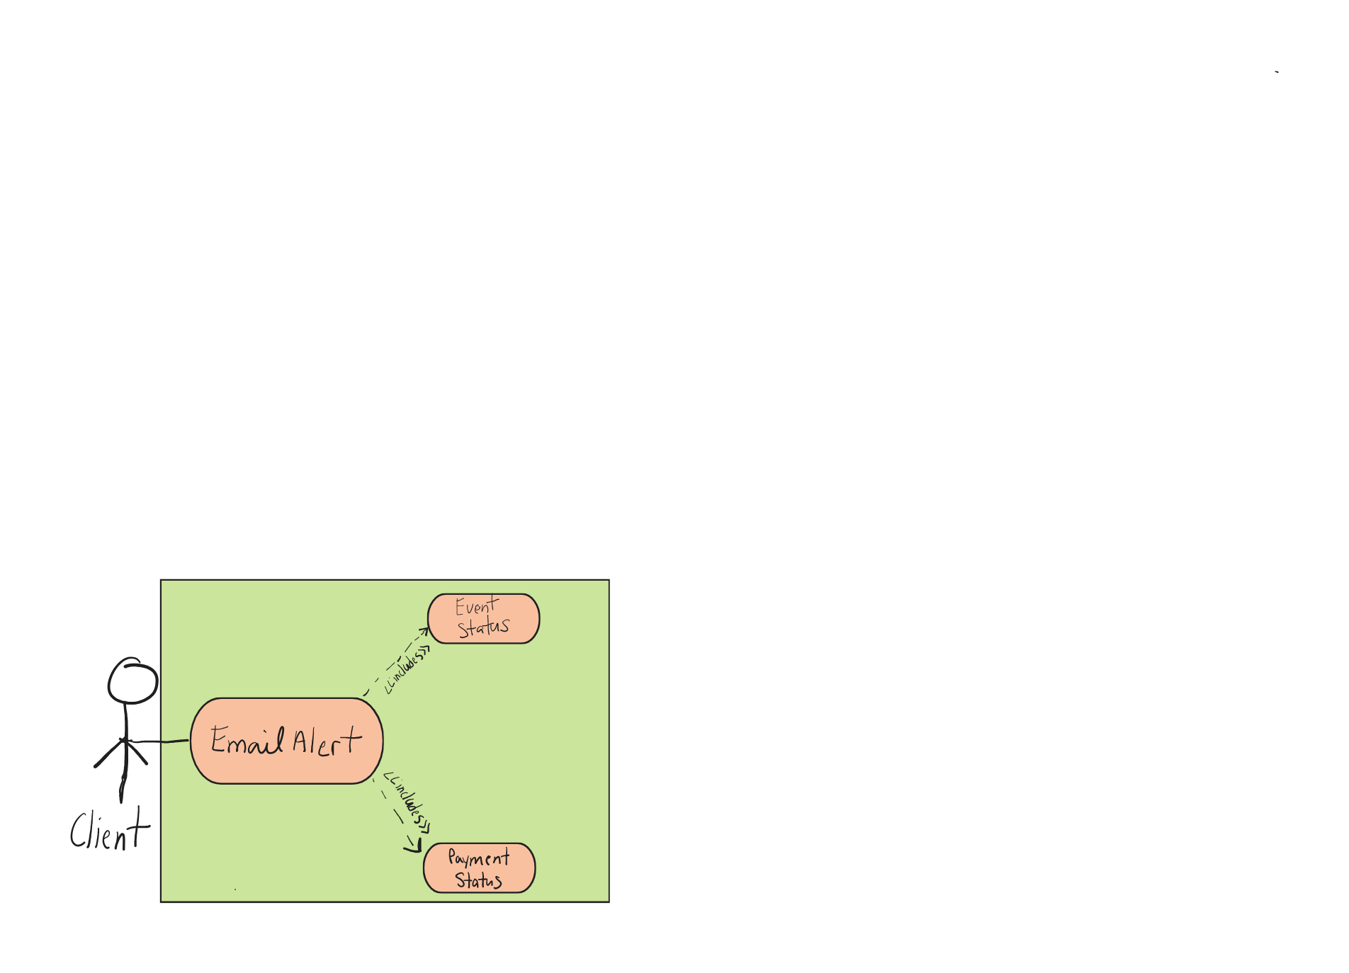
Use Case Name: ReceiveEmailNotification
Participating Actors: Client (system-triggered)
Description: System sends email notification when event status changes.
Flow of Events:
- Admin updates event status OR payment status changes.
- System generates notification.
- System sends email to client.
Entry Condition: Status change occurs.
Exit Conditions:
- Email sent
OR
- Email failure logged

PARK ADMIN USE CASES

4.13
UC-ADMIN-NOTIF: View Notification Bell
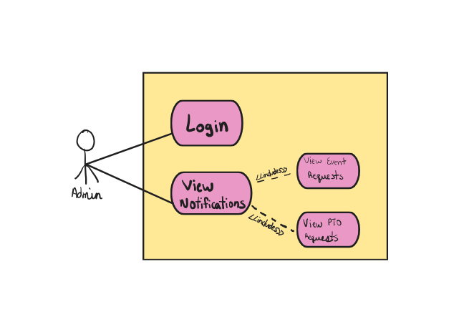
Use Case Name: AdminViewNotifications
Participating Actors: Park Admin
Flow of Events:
- Admin logs in.
- System displays notification bell.
- Admin selects bell icon.
- System displays event and PTO notifications.
- Admin selects notification.
- System redirects to request page.
Entry Condition: Admin logged in.
Exit Conditions:
- Notification opened
OR
- “No notifications” displayed

4.14
UC-REVIEW-EVENT: Review Event Request
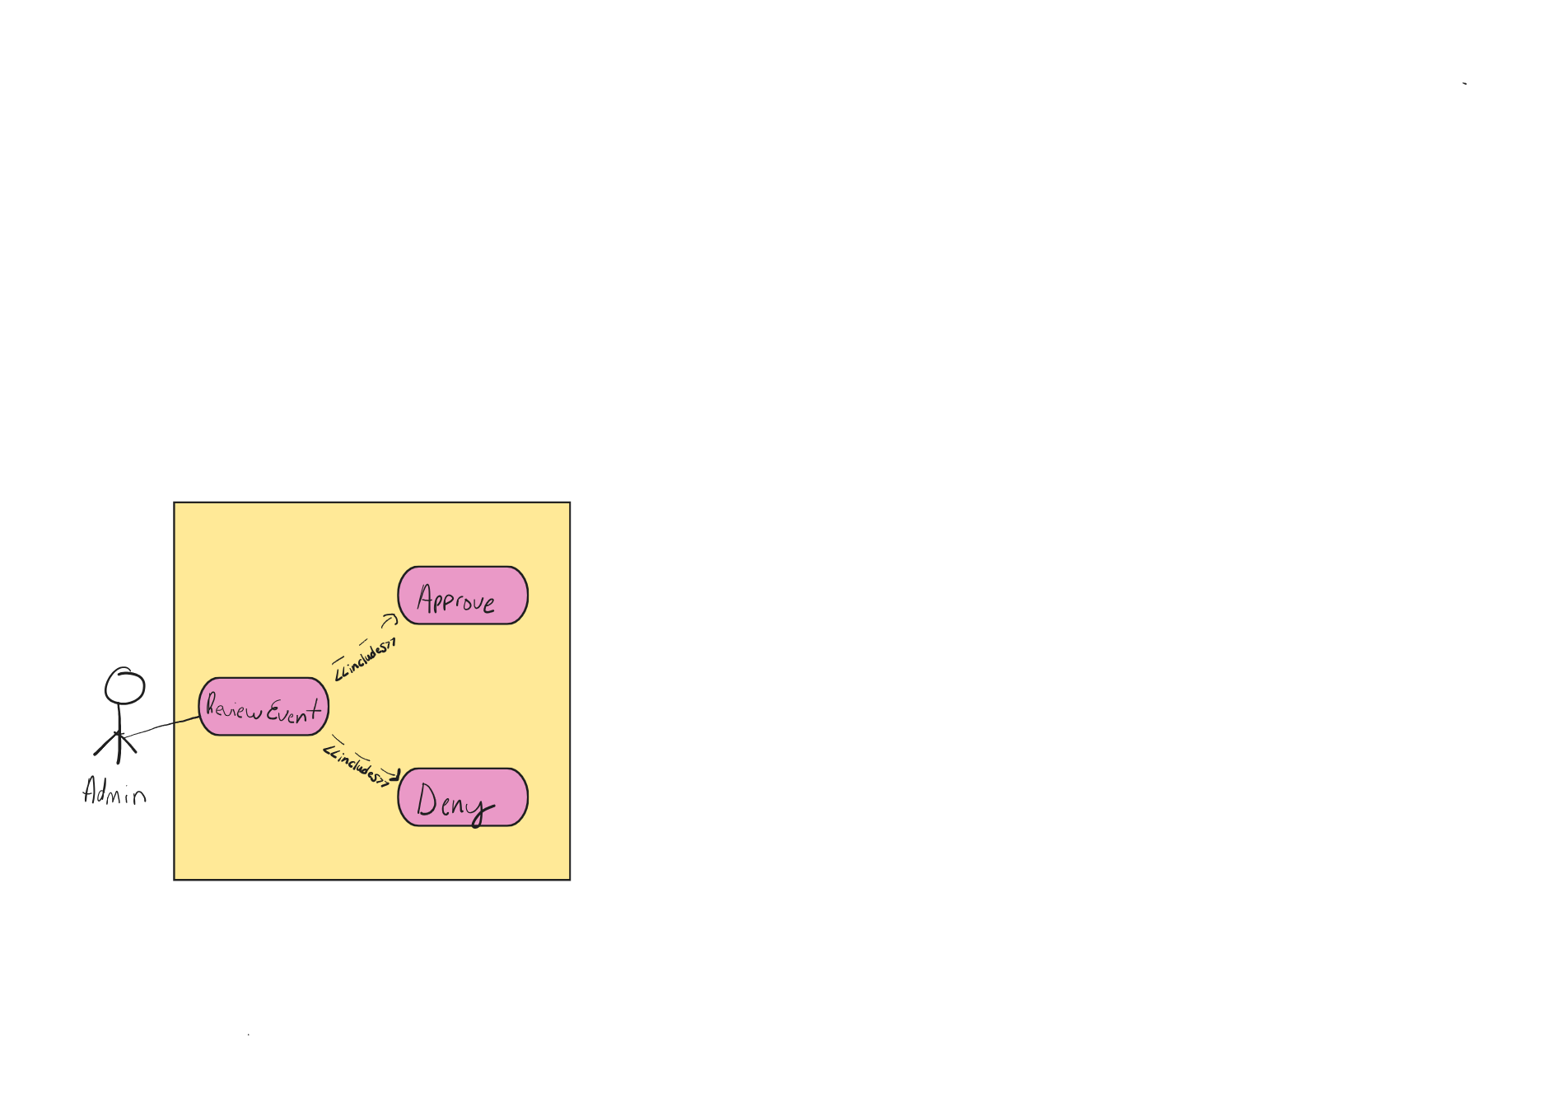
Use Case Name: ReviewEventRequest
Participating Actors: Park Admin
Flow of Events:
- Admin selects pending event.
- Admin reviews details.
- Admin selects Approve or Deny.
- System updates event status.
- System notifies Client.
Entry Condition: Pending event exists.
Exit Conditions:
- Event status updated
OR
- Error displayed

4.15
UC-MANAGE-EMPLOYEE: Manage Employee Account
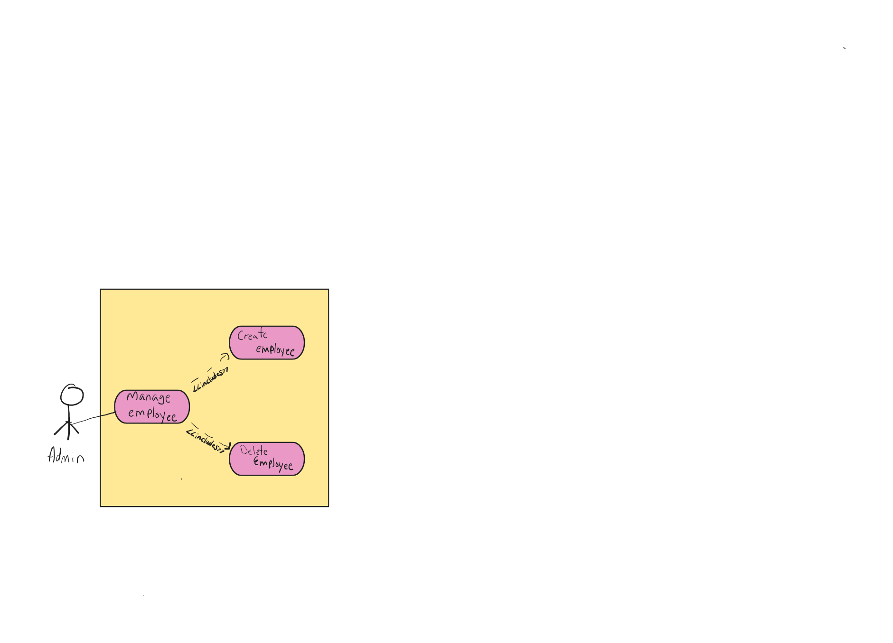
Use Case Name: ManageEmployeeAccount
Participating Actors: Park Admin
Flow of Events:
- Admin navigates to Employee Management.
- Admin selects Create or Delete.
- System processes request.
- System confirms action.
Entry Condition: Admin logged in.
Exit Conditions:
- Employee account created or deleted
OR
- Validation error displayed

4.16
UC-SCHEDULE-EMPLOYEE: Schedule Employee
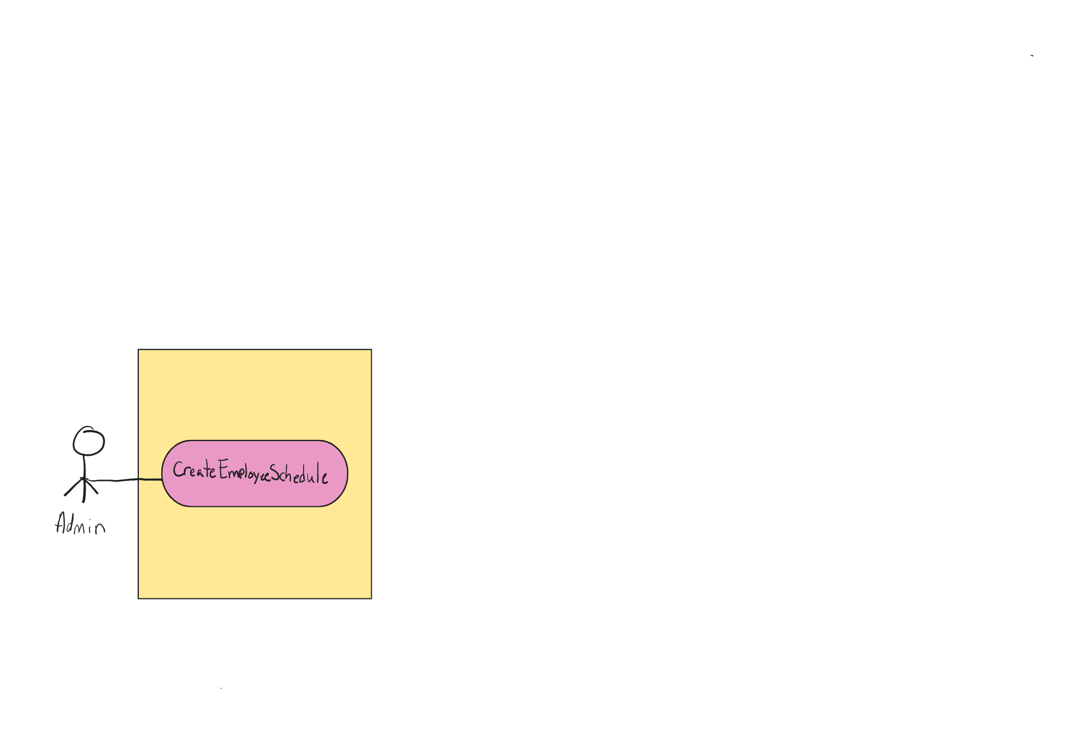
Use Case Name: CreateEmployeeSchedule
Participating Actors: Park Admin
Flow of Events:
- Admin selects approved event.
- Admin assigns employee and shift details.
- System saves schedule.
- System notifies employee.
Entry Condition: Approved event exists.
Exit Conditions:
- Schedule created
OR
- Error displayed

4.17
UC-REVIEW-PTO: Review PTO Request
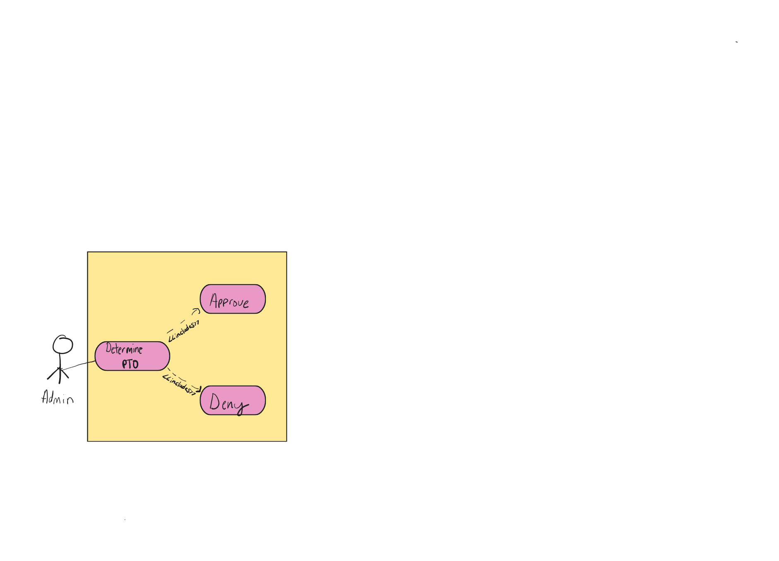
Use Case Name: DecidePTORequest
Participating Actors: Park Admin
Flow of Events:
- Admin selects PTO request.
- Admin reviews details.
- Admin selects Approve or Deny.
- System updates PTO status.
- System updates schedule if necessary.
Entry Condition: Pending PTO request exists.
Exit Conditions:
- PTO decision recorded
OR
- Error displayed

EMPLOYEE USE CASES
4.18
UC-VIEW-SCHEDULE: View Schedule
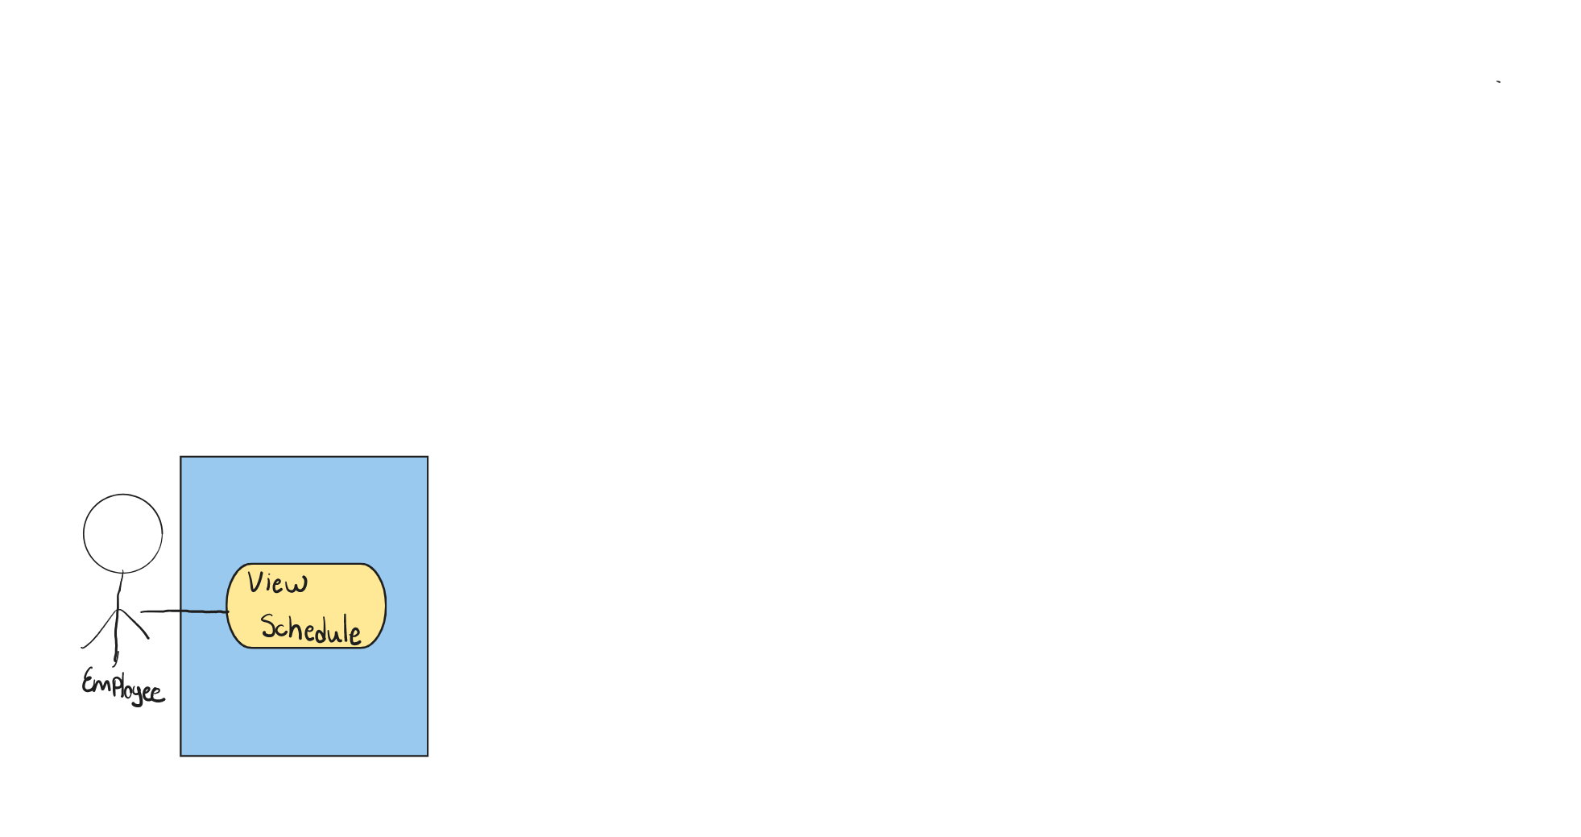
Use Case Name: ViewSchedule
Participating Actors: Employee
Flow of Events:
- Employee logs in.
- Employee selects “My Schedule.”
- System displays assigned shifts.
Entry Condition: Employee logged in.
Exit Conditions:
- Schedule displayed
OR
- “No shifts assigned” message

4.19
UC-REQUEST-PTO: Request PTO
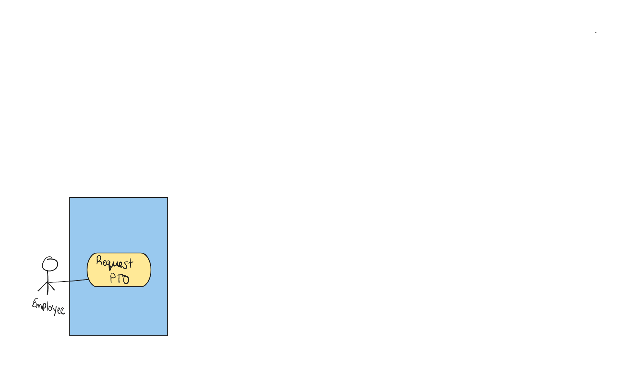
Use Case Name: RequestPTO
Participating Actors: Employee
Flow of Events:
- Employee opens PTO form.
- Employee enters dates and reason.
- Employee submits request.
- System records PTO as “Pending.”
- System notifies Admin.
Entry Condition: Employee logged in.
Exit Conditions:
- PTO recorded
OR
- Validation error displayed

5. Flow Chart – Diagrams
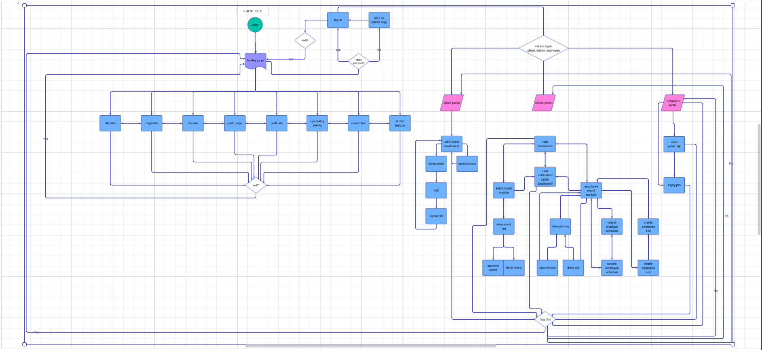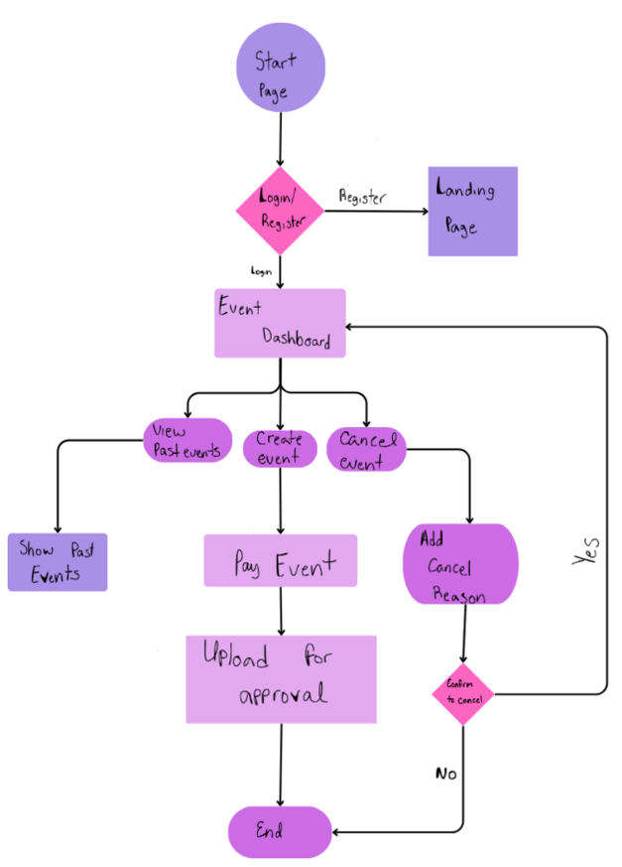
Event booking – flow chart
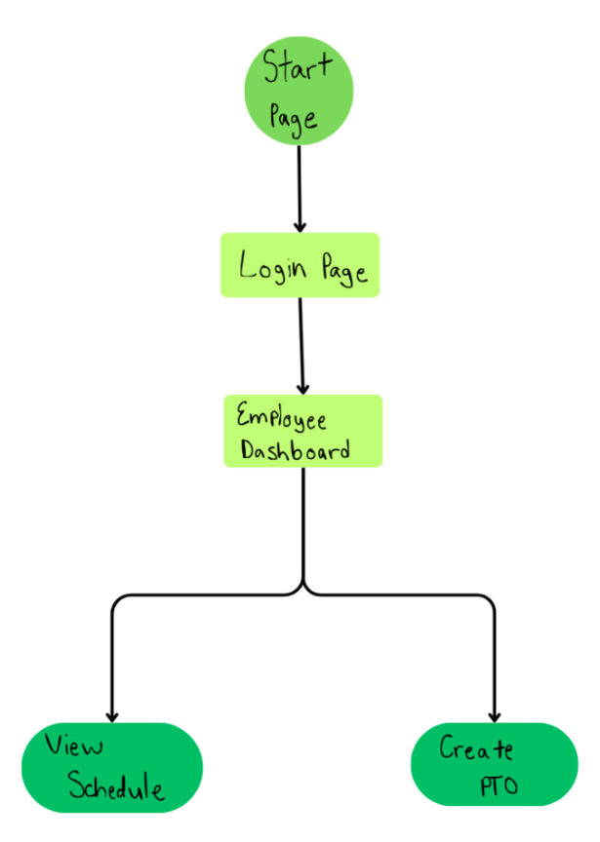
Employee user – flow chart
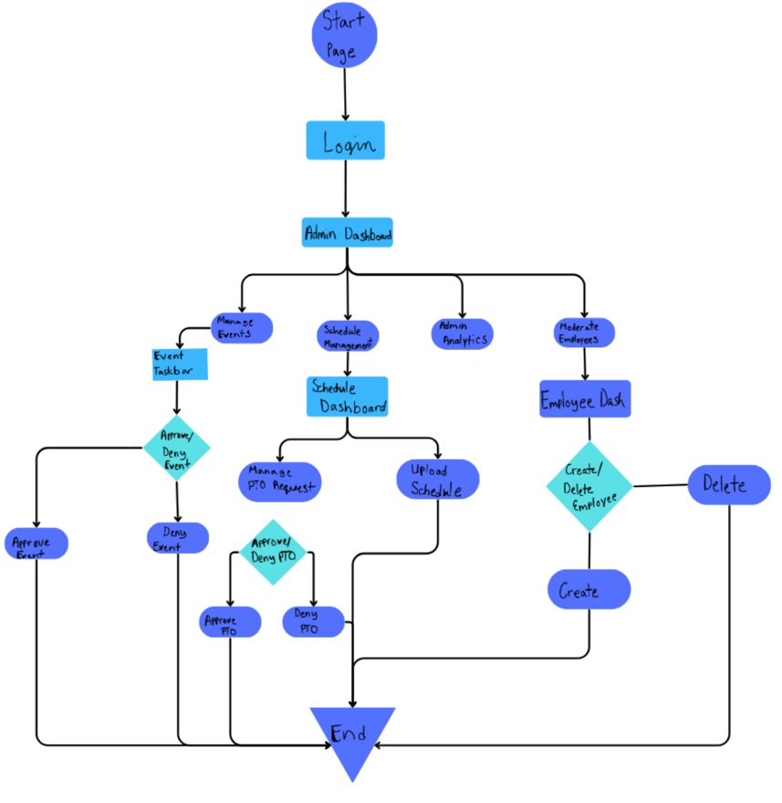Park Administrator - Flow chart

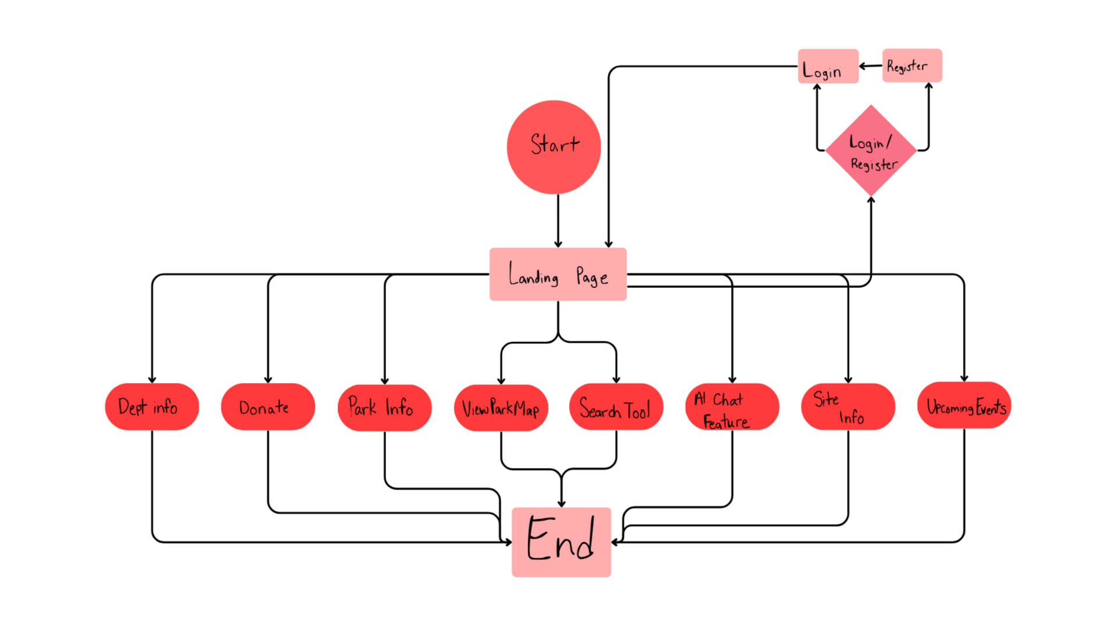Guest User - Flowchart

6. References
- Amazon Web Services. (2023). AWS Architecture Center. https://aws.amazon.com/architecture
- International Organization for Standardization & International Electrotechnical Commission. (2011). ISO/IEC 25010:2011 Systems and Software Engineering — Systems and Software Quality Requirements and Evaluation (Square).
- Lucid Software Inc. (2024). Lucidchart. https://www.lucidchart.com
- Mozilla Developer Network. (2024). MDN Web Docs. https://developer.mozilla.org
- National Institute of Standards and Technology. (2022). Digital Identity Guidelines (NIST SP 800-63-3). https://pages.nist.gov/800-63-3/
- New York State Office of Parks, Recreation and Historic Preservation. (n.d.). New York State Parks. https://parks.ny.gov/
- Object Management Group. (2017). Unified Modeling Language (UML) Version 2.5.1 Specification. https://www.omg.org/spec/UML/2.5.1
- OpenAI. (2024). OpenAI API documentation. https://platform.openai.com/docs
- OWASP Foundation. (2023). OWASP Top 10: Web Application Security Risks. https://owasp.org
- Pressman, R. S., & Maxim, B. R. (2020). Software Engineering: A Practitioner’s Approach (9th ed.). McGraw-Hill.
- Sommerville, I. (2016). Software Engineering (10th ed.). Pearson.
- SUNY Old Westbury. (2024). Brightspace Learning Management System – Assignment Instructions and Course Materials.
- SUNY Old Westbury. (2024). Concept Document Template.
- SUNY Old Westbury. (2024). Use Case Examples.
- SUNY Old Westbury. (2024). AniPals Sample Project.
- SUNY Old Westbury. (2024). Maze Mirage Sample Project.
- SUNY Old Westbury. (2024). MusicDen Sample Project.
- World Wide Web Consortium. (2018). Web Content Accessibility Guidelines (WCAG) 2.1. https://www.w3.org/TR/WCAG21/
- ZyBooks. (n.d.). Internet and web technologies. https://www.zybooks.com
- Google. (n.d.). Google Search. https://www.google.com
- YouTube. (n.d.). YouTube video platform. https://www.youtube.com
- API GOOGLE CLOUD. https://cloud.google.com/apis?hl=en

7. Key Terms
Core System Roles
- Guest – A public user who accesses park and department information without logging in.
- Client – A registered user who submits event booking requests, manages reservations, uploads ID if required, and completes payments.
- Park Administrator (Admin) – Authorized personnel responsible for reviewing/approving event requests and PTO, managing employee accounts, scheduling, notifications, and analytics.
- Employee – Park staff member who views assigned schedules and submits PTO requests.
Functional Terms
- Event Request – A client-submitted reservation request awaiting administrative review.
- Event Lifecycle – The workflow of event submission → pending review → approval/denial → payment (if required) → scheduling → completion/cancellation.
- Pending Status – State indicating a request (event or PTO) is awaiting administrative decisions.
- Approved Status – State indicating a request has been accepted.
- Denied Status – State indicating a request has been rejected.
- Cancelled Status – State indicating a client cancelled an eligible reservation.
- Payment Validation (Mock) – Simulated payment verification used for demonstration/testing purposes.
- ID Verification Upload – Client document upload requirements for compliance/safety and incident handling.
- Notification Bell – In-application alert hub for Admin (event requests, PTO requests, and status changes).
- Email Notification – Automated email triggered by event status changes or payment updates.
- Dashboard Analytics – Administrative reporting visuals (bookings, participation, donations, usage metrics).
- RBAC (Role-Based Access Control) – Security approach restricting functionality by user role.
- Authentication – Verifying identity (login).
- Authorization – Granting permissions after authentication.
- API (Application Programming Interface) – Interface enabling integrations (maps, AI chatbot, search services).
- Responsive Design – UI design that adapts across desktop/tablet/mobile screens.
- DBMS (Database Management System) – Stores users, events, payments, schedules, PTO requests, and logs.
- Search & Filtering – Tooling to locate parks/events via keywords, categories, dates, and location (where supported).
- Audit Logging – Recording important system actions for troubleshooting and accountability.
- Accessibility (WCAG) – Standards ensuring usability for users with disabilities (keyboard navigation, contrast, screen-reader support).
- Data Privacy – Protection of user identity, documents, and payment-related data.
- Encryption – Securing sensitive data in transit and/or at rest.

8. Contributions
CONTRIBUTIONS:
DANY:
- entire concept document - wording
- Main Overall - Flow Chart Diagram (UML)
- Main Overall - Use Case Diagram (UML)
- powerpoint presentation - slides, design, texts, illustrations
- reviewed all of davina work
Davina:
- 19 detailed use case diagrams (hand drawn)
- detailed flow chart diagrams - user work flows (hand drawn)
- presentation - diagrams (hand drawn)
- final spell check & editing

